CIS 61 :: Lab 02 - Functions and Control

Student Name:

Instructions: Use Sublime Text to write and use Command Line execute below programs. Attach Snipping photos of your source code and executions of the code in Python shell (or run a doc test). You can create a separate Python file for each exercise. Make sure to submit this template as a single file with all of your solutions. Do not zip your file.
[DO NOT USE THE FOR LOOP, LISTS or RECURSION IN ANY OF YOUR SOLUTIONS]

Part 1 - Functions and Control

Q1: Fix the Bug
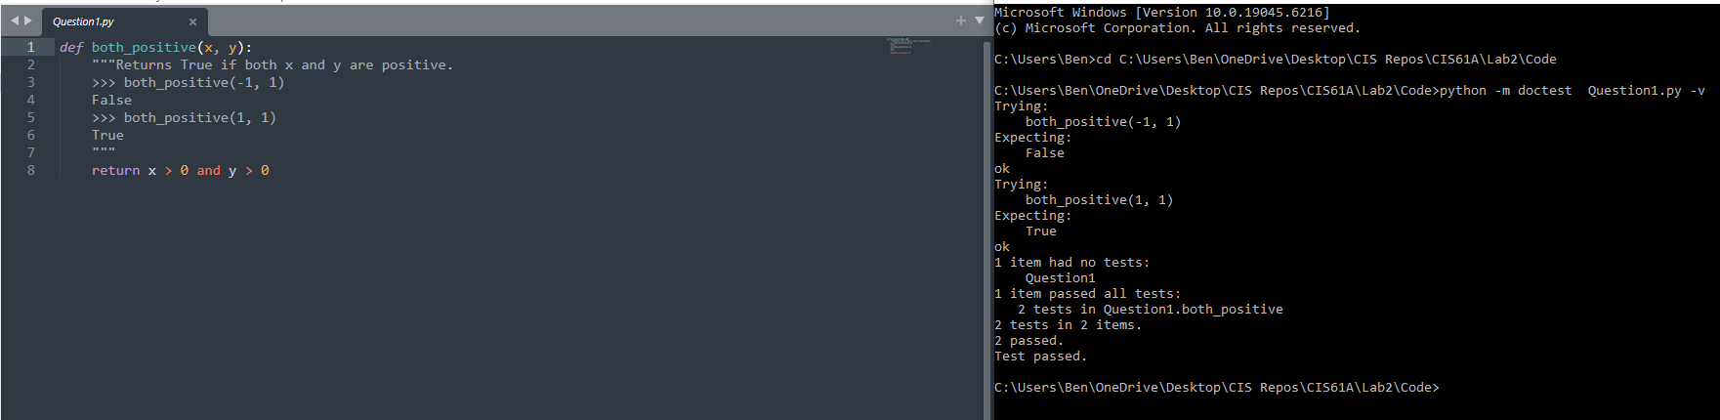

Q2: A Plus Abs B
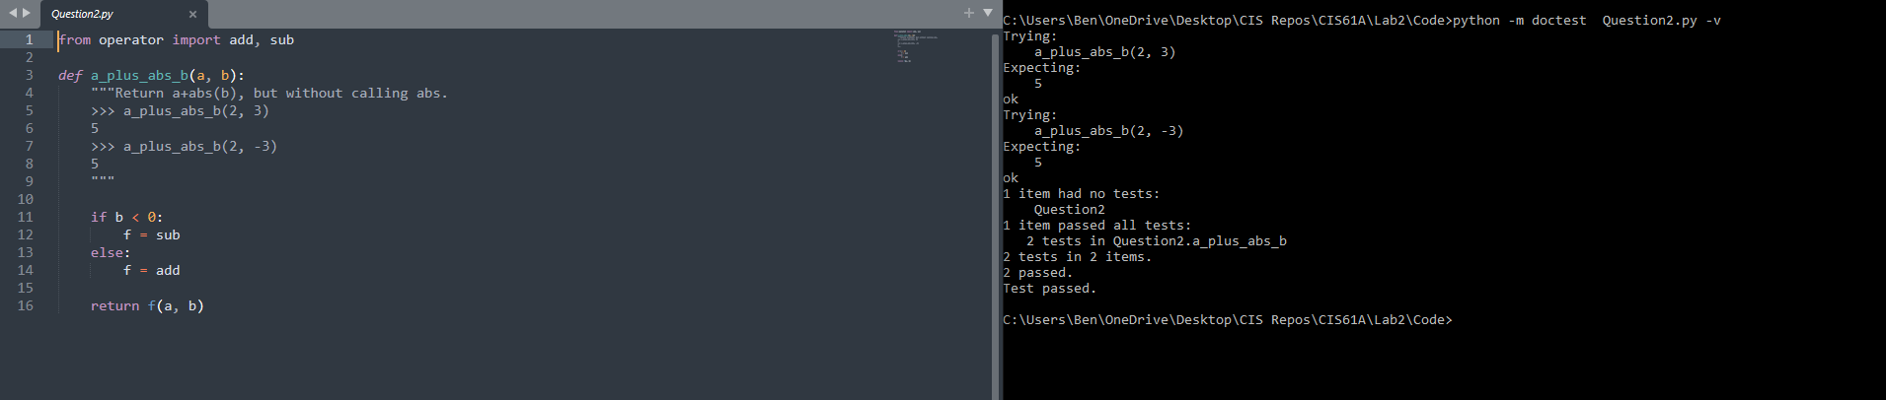

Q3: Two of Three
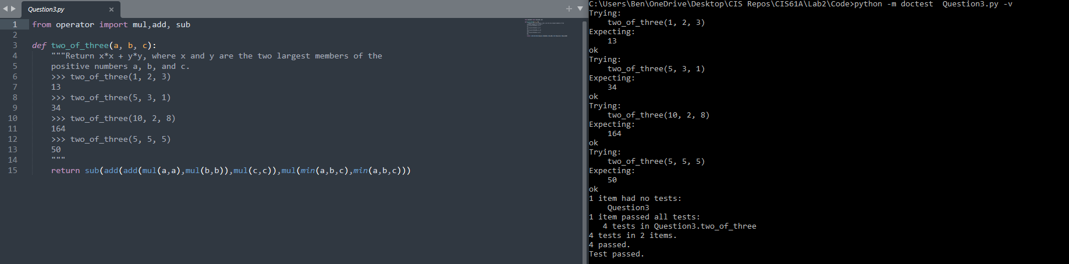

Q4: Largest Factor
Write a function that takes an integer n that is greater than 1 and returns the largest integer that is smaller than n and evenly divides n.
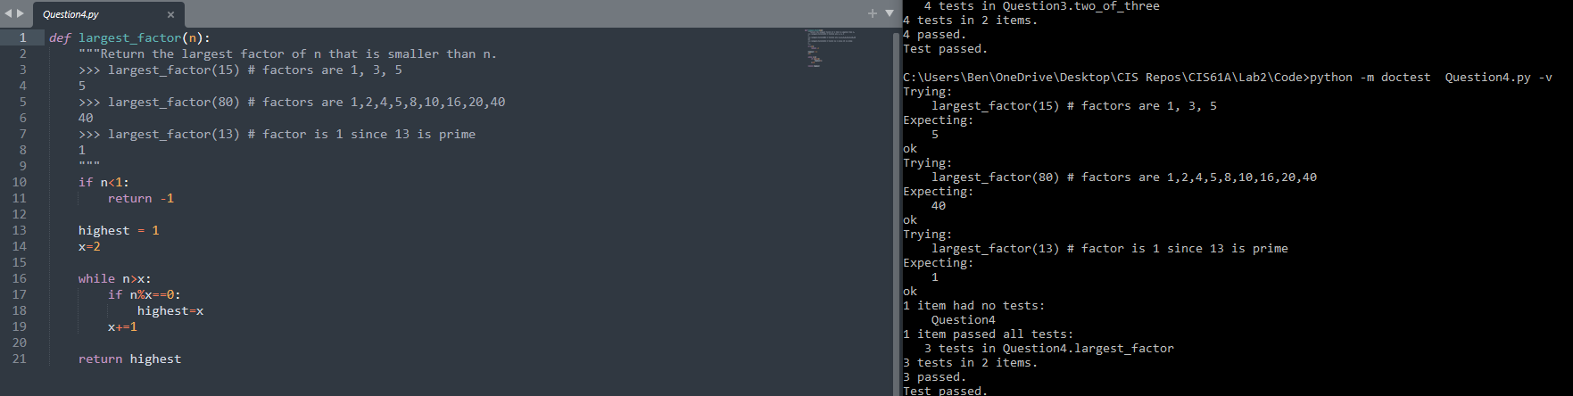

Q5: Sum Digits
Write a function that takes in a nonnegative integer and sums its digits. (Using floor division and modulo might be helpful here!)
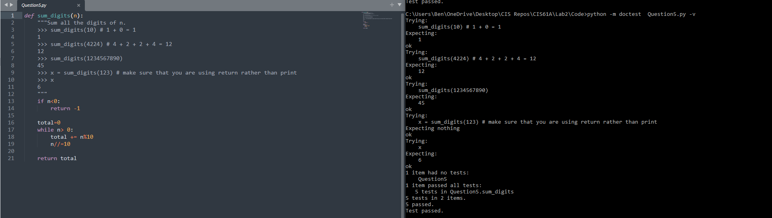

Q6: Hailstone
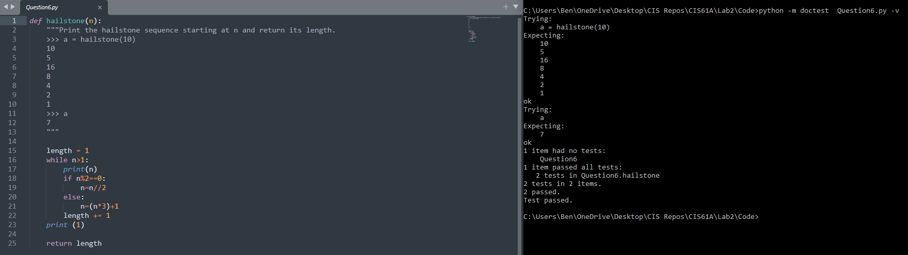
Hailstone sequences can get quite long! Try 27. What's the longest you can find?

Q7: Fibonacci Number
Write a function to compute the nth Fibonacci number. DO NOT USE RECURSION.
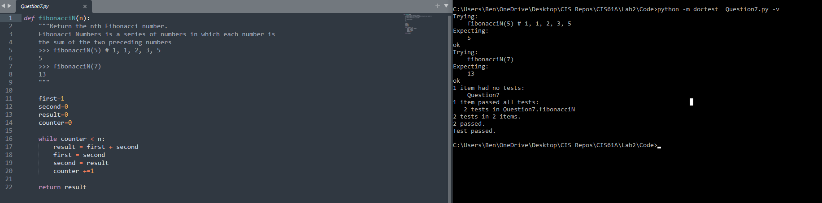

Q8: Is Prime?
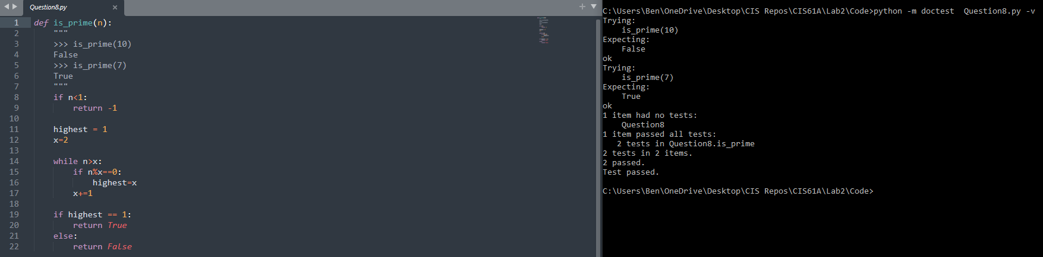

Part 2 - Environment Diagram
For the below questions you can use the drawing tool or write your solution on a piece of paper and then take a picture and add the picture under the question.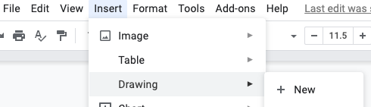

Q9: Assignment statements, such as x = 3, define variables in programs. To execute
one in an environment diagram, record the variable name and the value:
- Evaluate the expression on the right side of the = sign
- Write the variable name and the expression's value in the current frame.

Use these rules to draw a simple diagram for the assignment statements below.
a = 3
b = 4
def square(x):
return x * x

def sum_of_squares(x, y):
return square(x) + square(y)

c = sum_of_squares(a, b)
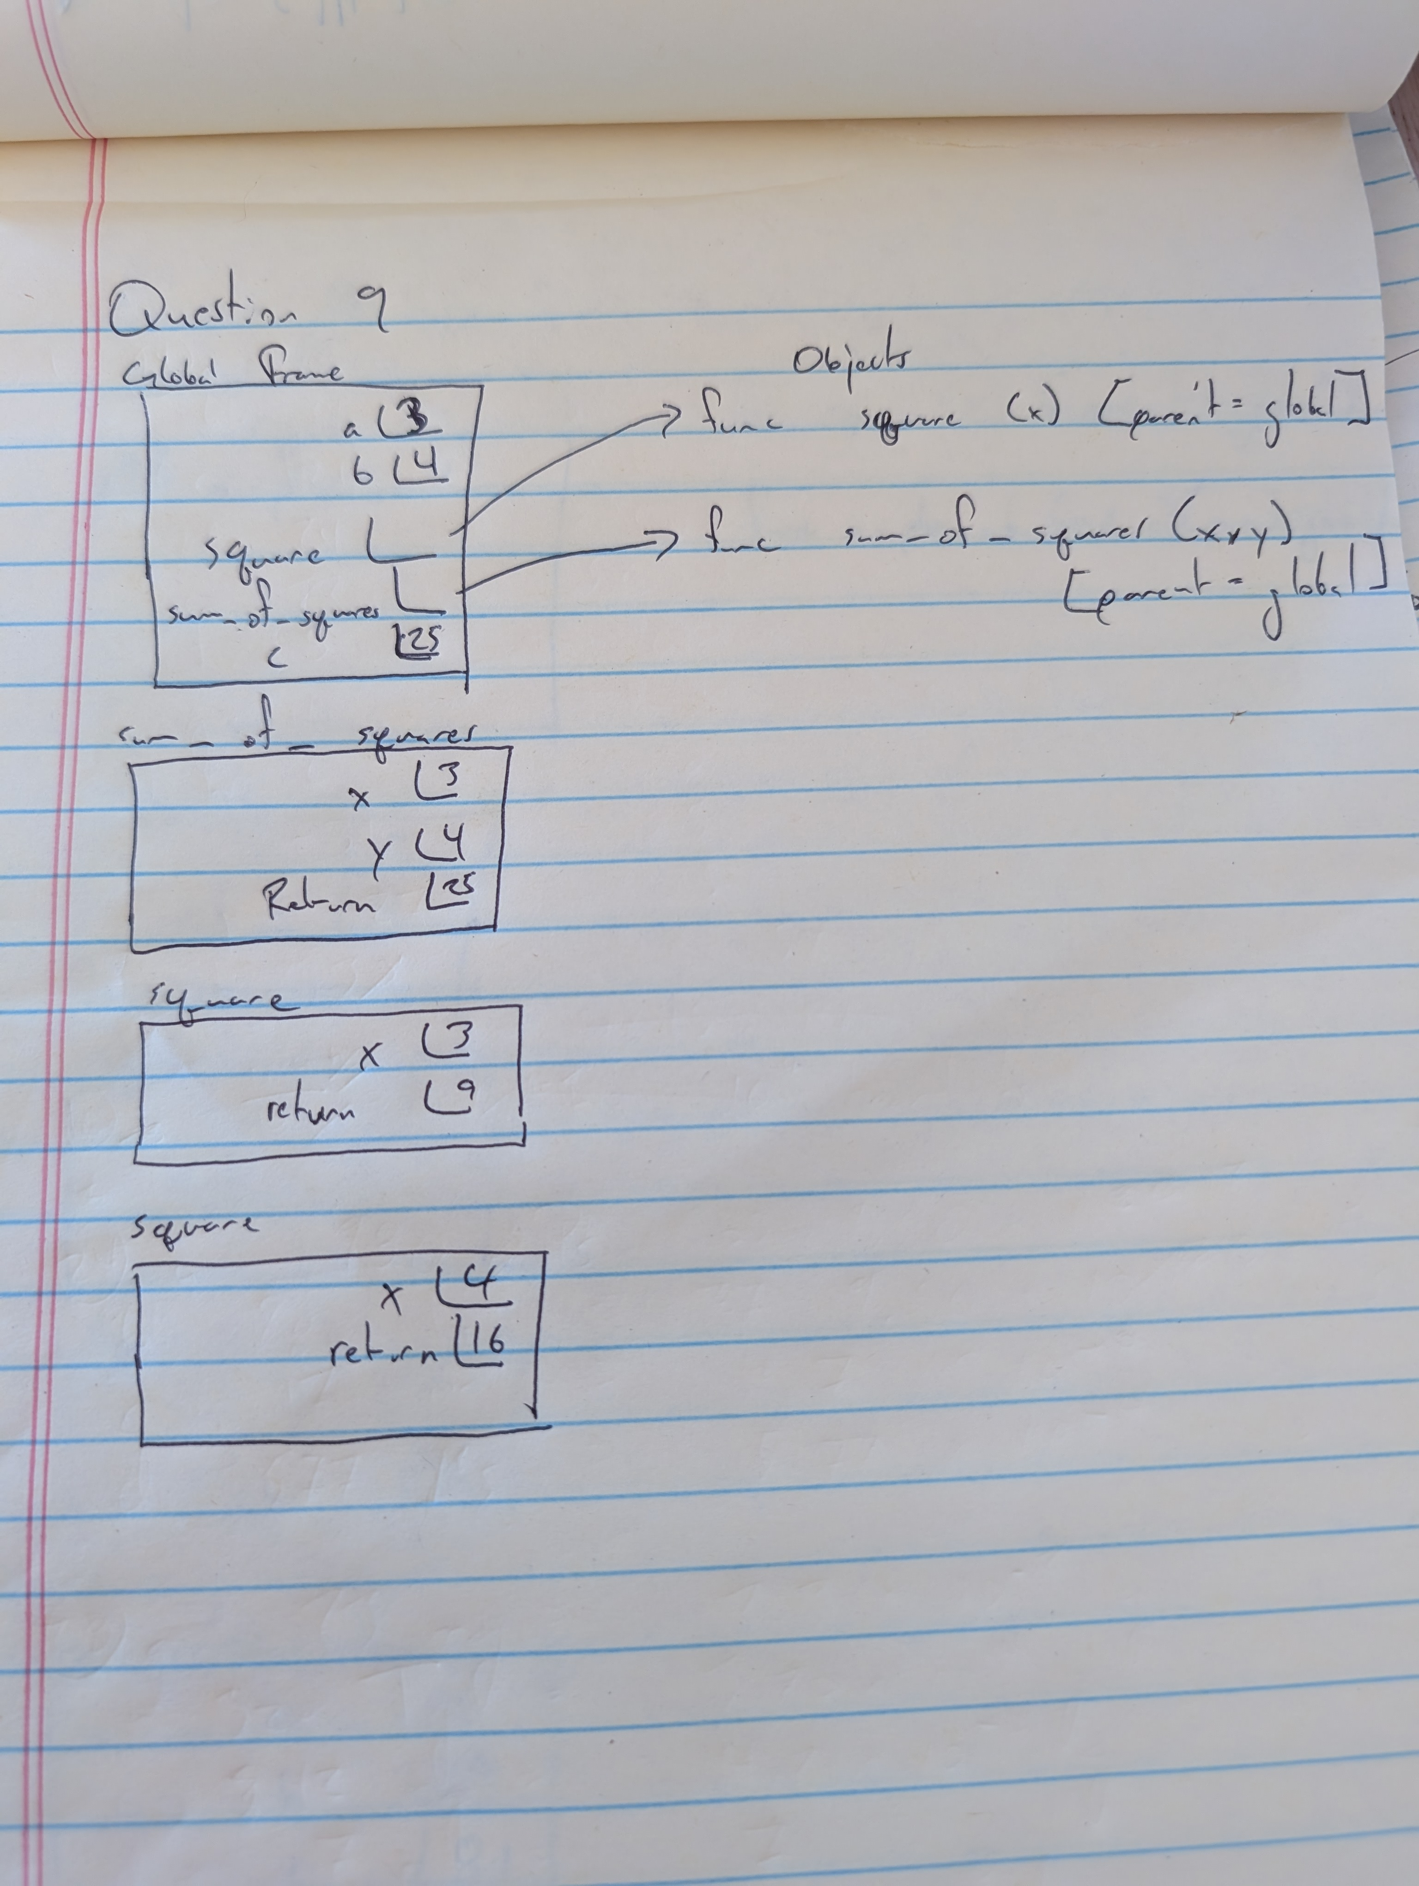

Q10: Call expressions, such as square(2), apply functions to arguments. When executing call expressions, we create a new frame in our diagram to keep track of local variables:
- Evaluate the operator, which should evaluate to a function.
- Evaluate the operands from left to right.
- Draw a new frame, labeling it with the following:
  - A unique index (f1, f2, f3, ...)
  - The intrinsic name of the function, which is the name of the function object itself.
For example, if the function object is func square(x)
[parent=Global], the intrinsic name is square.
  - The parent frame ([parent=Global])
- Bind the formal parameters to the argument values obtained in step 2 (e.g. bind x to 3).
- Evaluate the body of the function in this new frame until a return value is obtained. Write down the return value in the frame.

If a function does not have a return value, it implicitly returns None. In that case, the “Return value" box should contain None.

Let's put it all together! Draw an environment diagram for the following code.
def square(x):
return x * x

def a_plus_bc(a, b, c):
bc = b * c
return a + bc

a_plus_bc(square(2), 3, square(square(3)))
